API Tests done: http://localhost:3001/api-docs/swagger (Products)

- Add Product in the database:
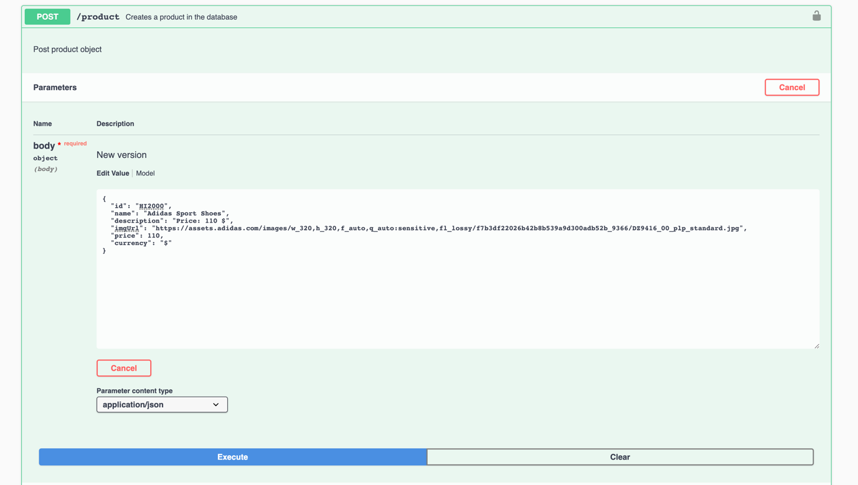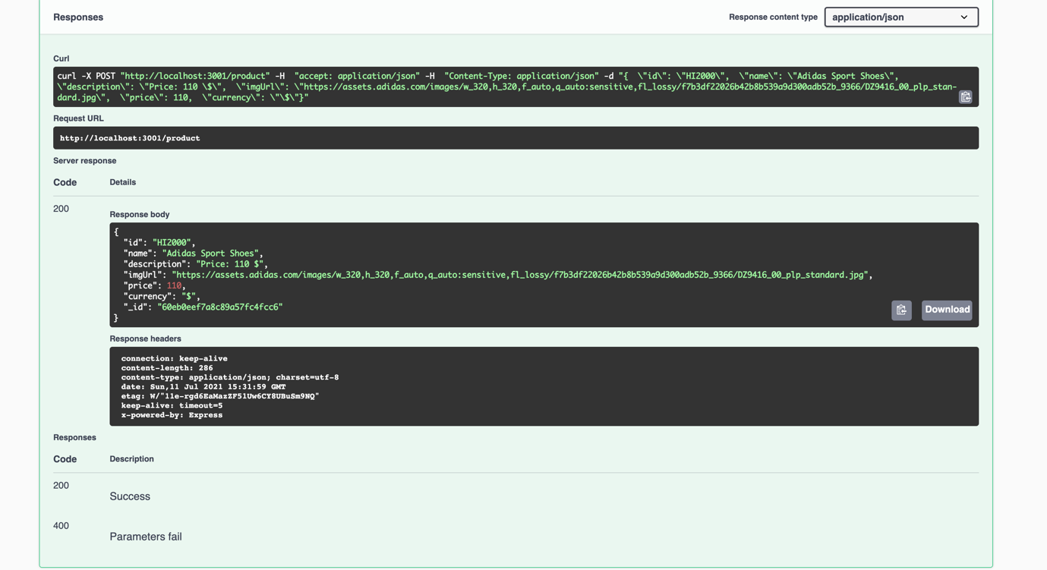

- View Recently added Product by ID:
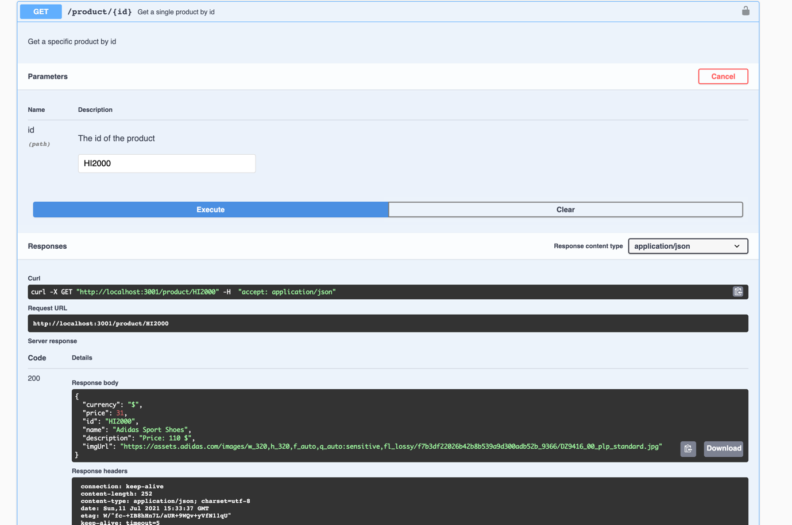

Bug found: While adding product the price is mentioned in the API POST method as 110 but while using GET method price is showing as 31

- (Negative Test) Try to retrieve product which is unavailable in the database
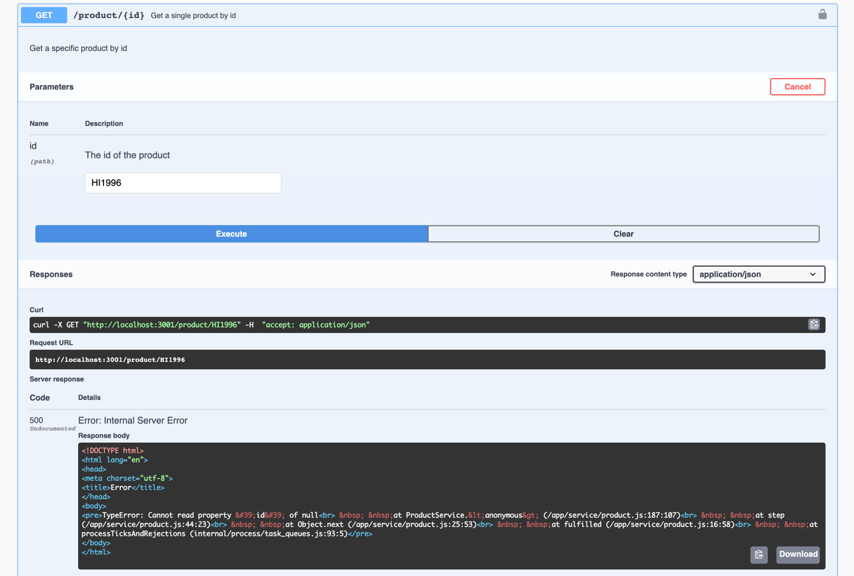

- Delete Product from Database
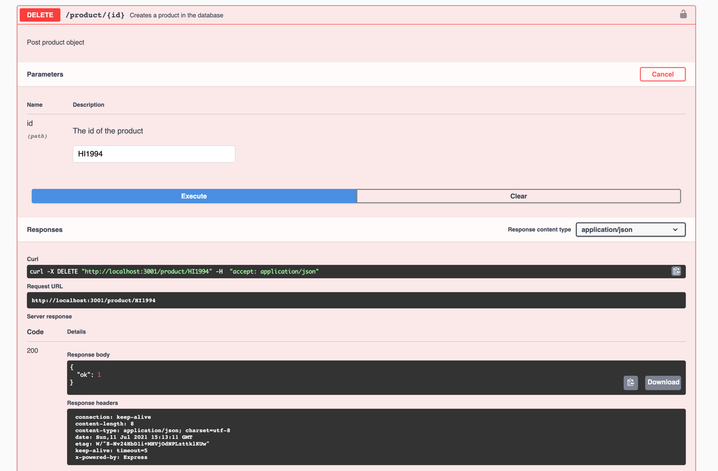

- Try to get recently deleted product from database
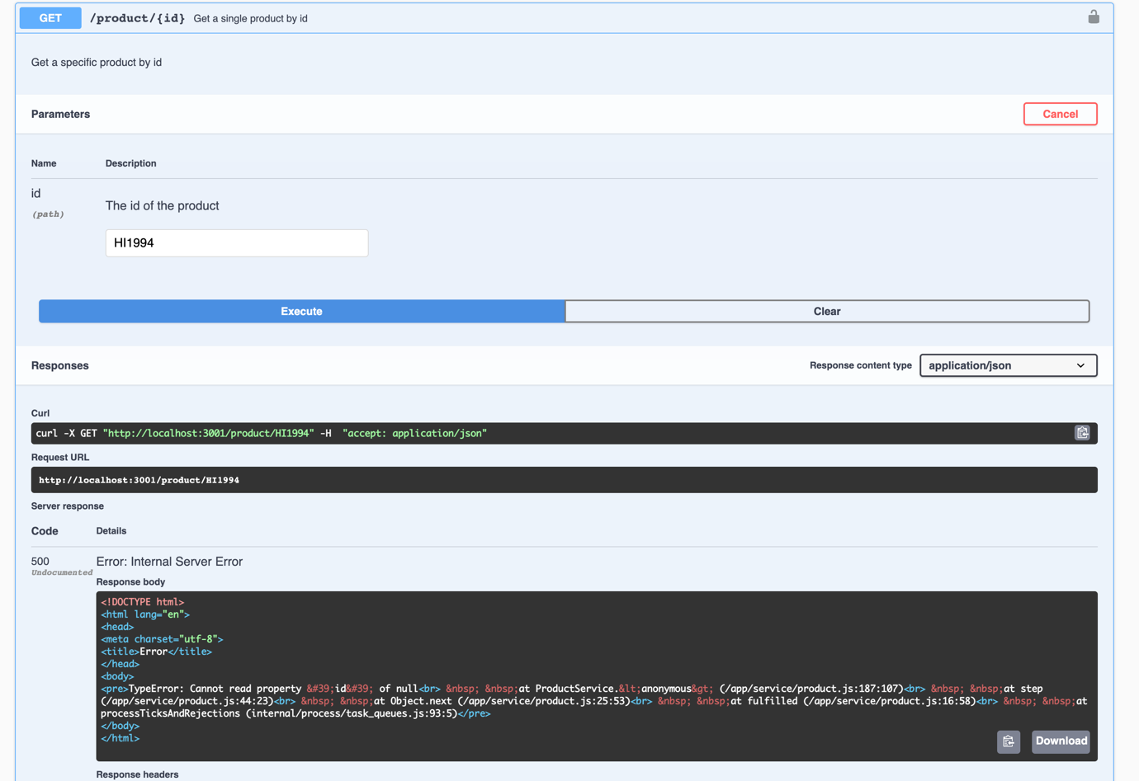

- Get all product list
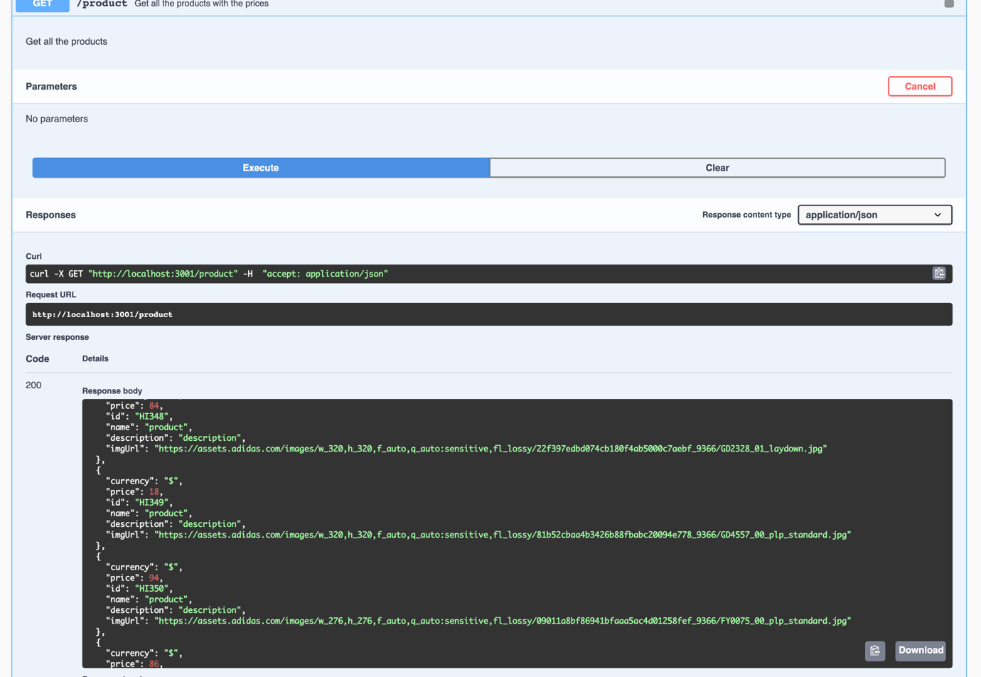

- Check the newly added product can retrieved via GET all product list
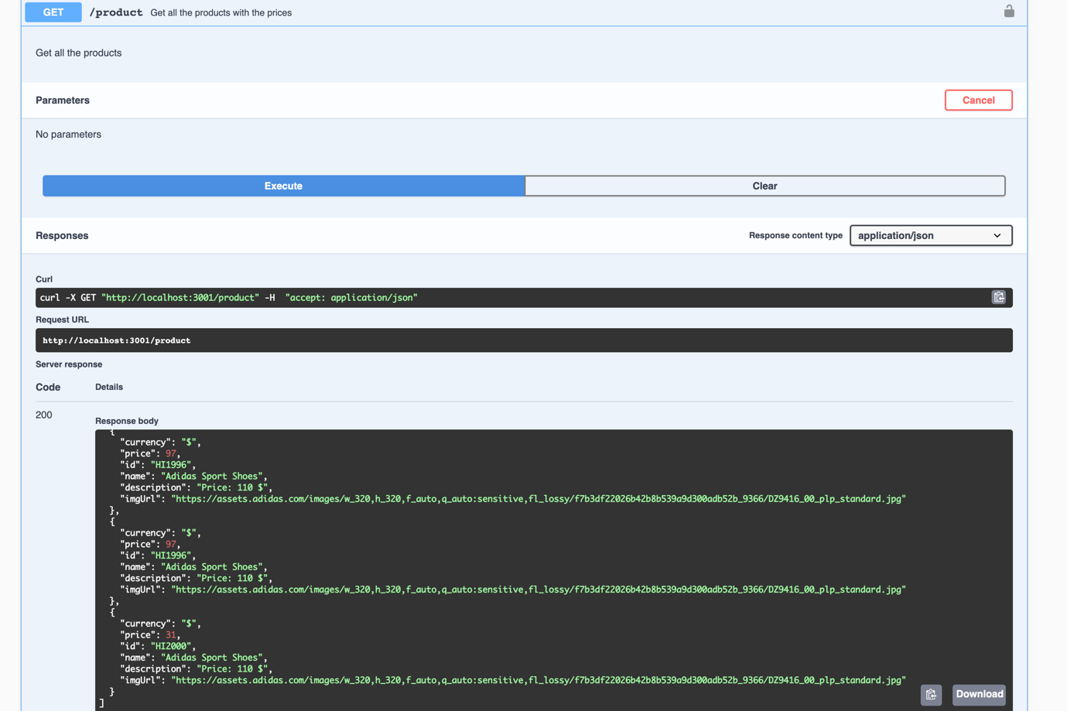

API Tests done: http://localhost:3002/api/#/ (Review)
- (Negative Test) Add review for the product which is unavailable in the database
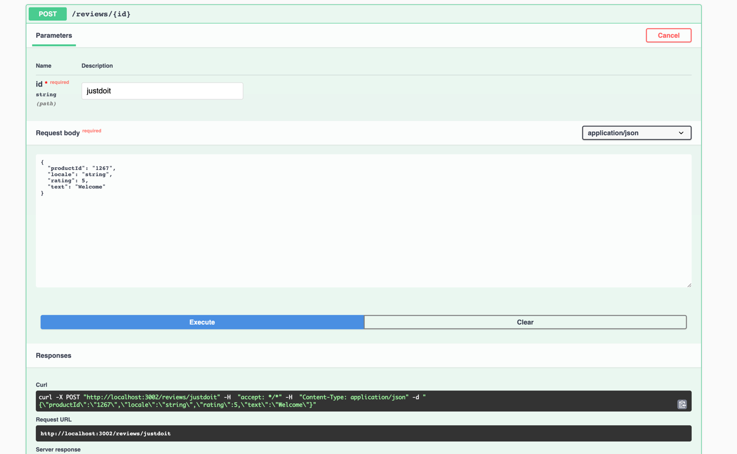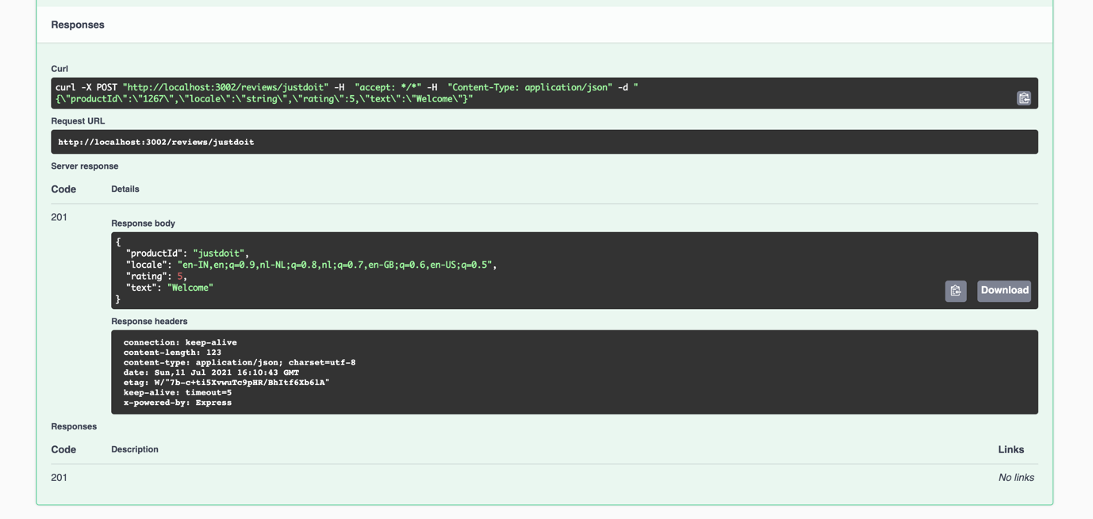

Bug found: Here product id “justdoit” is unavailable in the database but still review got added via API service.

- Add product Review
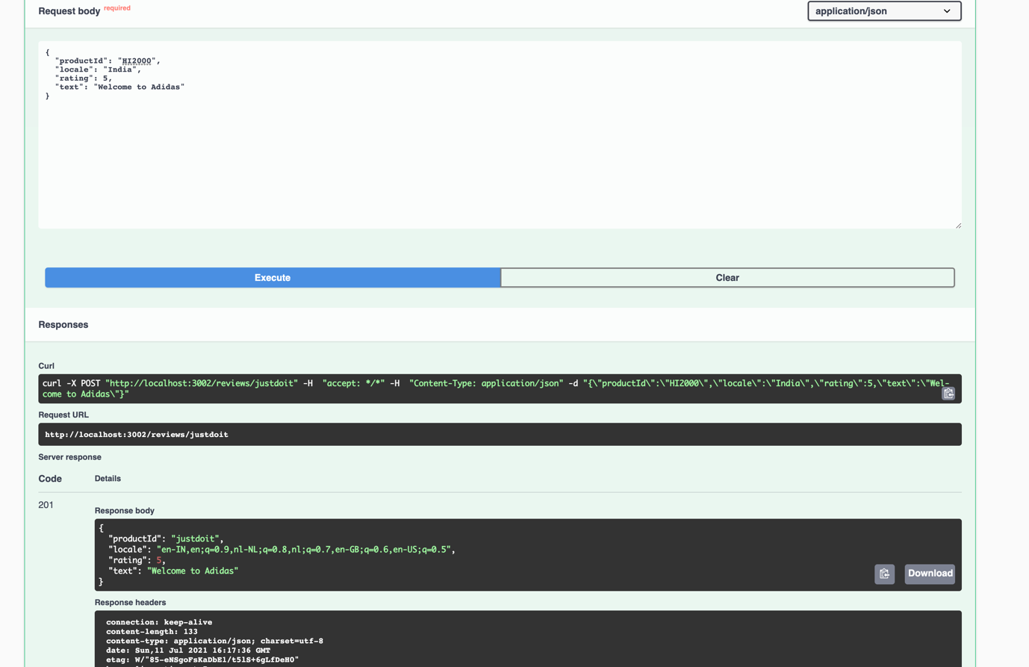

- Get Recently added Review
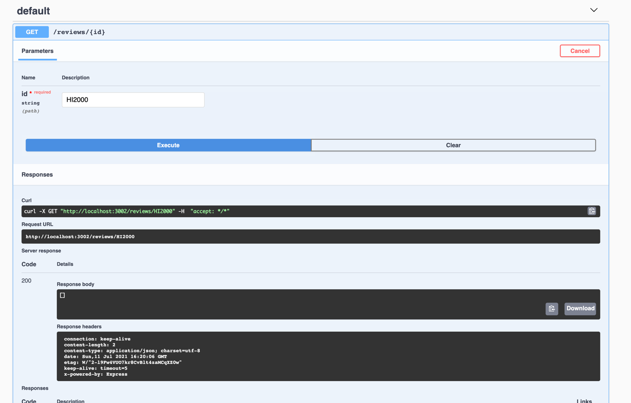

- Get Review which is not the review list
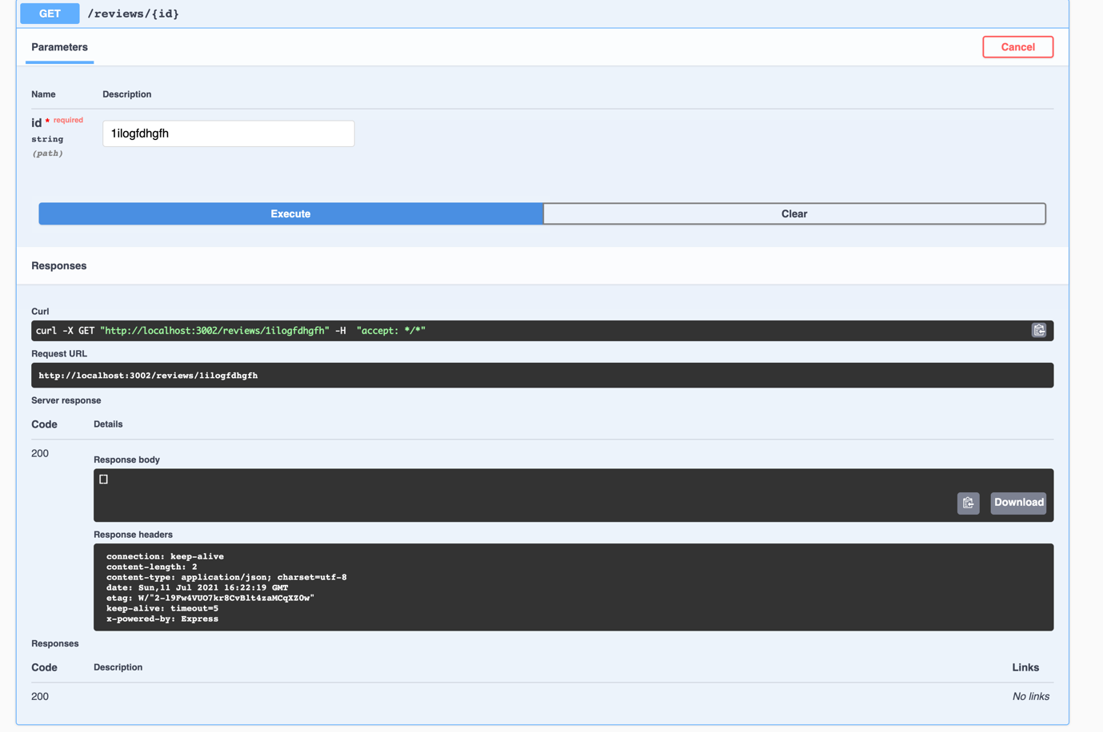

Bug found: queried for review id which is unavailable still the response code is 200.

